

LAB NO.6

DEPARTMENT COMPUTER SYSTEM ENGINEERING

NAME MUHAMMAD SADEEQ

ROLL NUMBER 75025

SECTION C

SUBMITTED TO SIR ABDULLAH HAMID

SENDING AN EMAIL WITH ATTACHMENT THAT HAS SIZE MORE THAN 30MB

1. **OPEN CHROME IN YOUR PC**

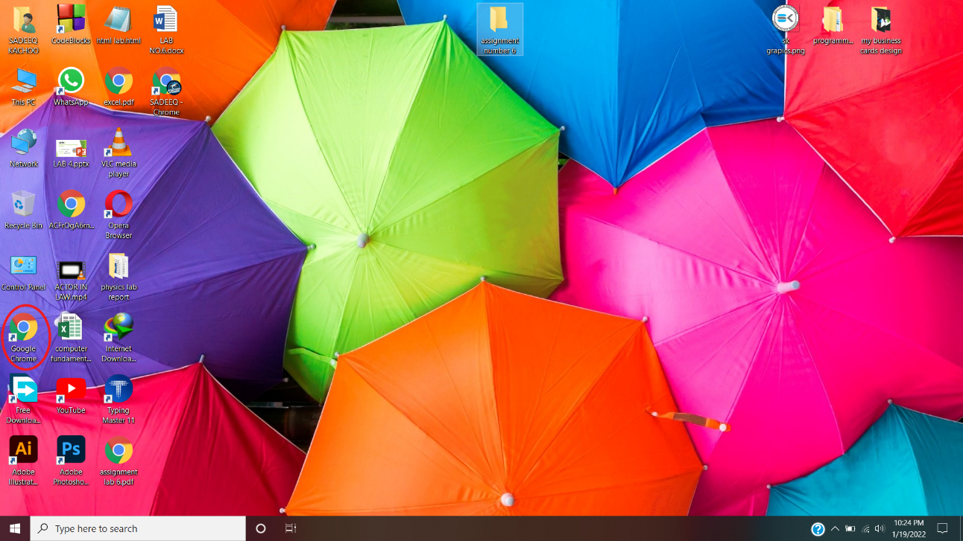

1. **OPEN GOOGLE DRIVE IN CHROME**

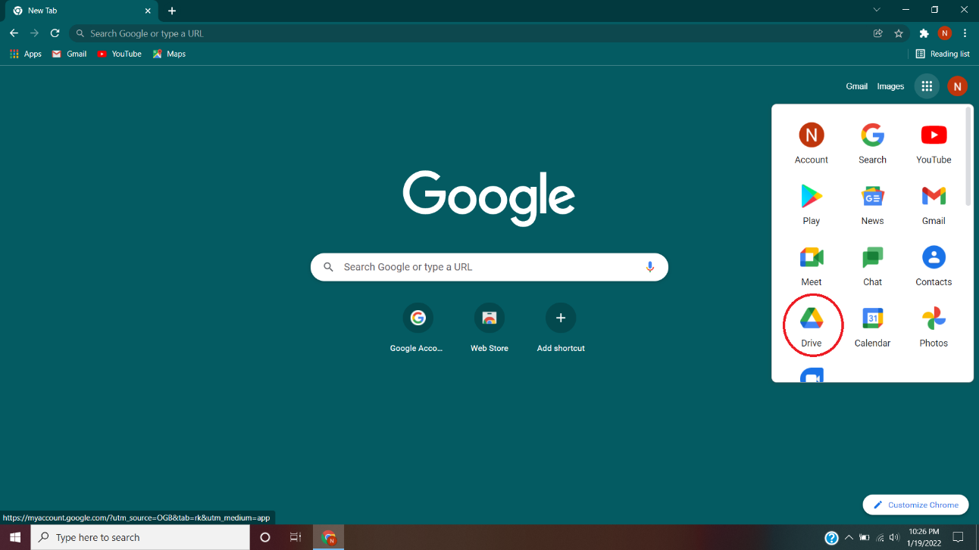

1. **CLICK ON UPLOAD FILE**

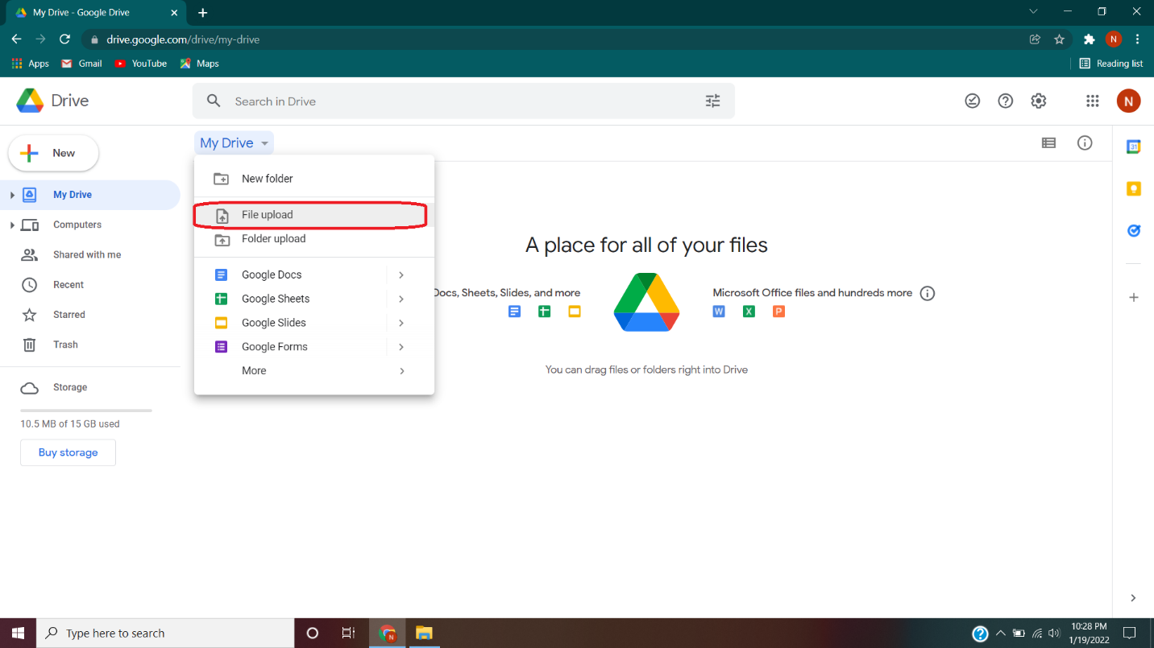

1. **SELECT THE FILE YOU WANT TO SENT THEN CLICK OPEN**

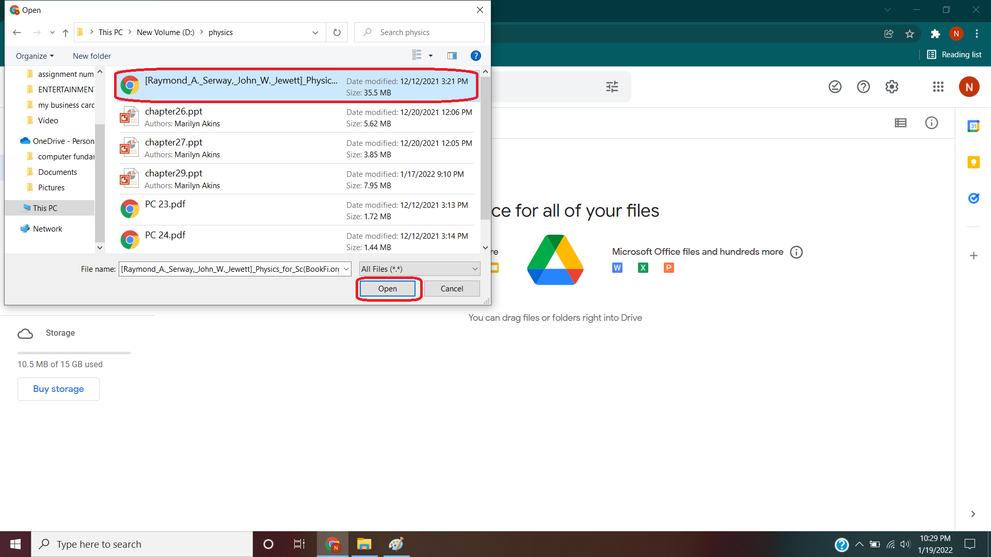

1. **FILE WILL START UPLOADING IT WILL TAKE FEW MINIUTES**

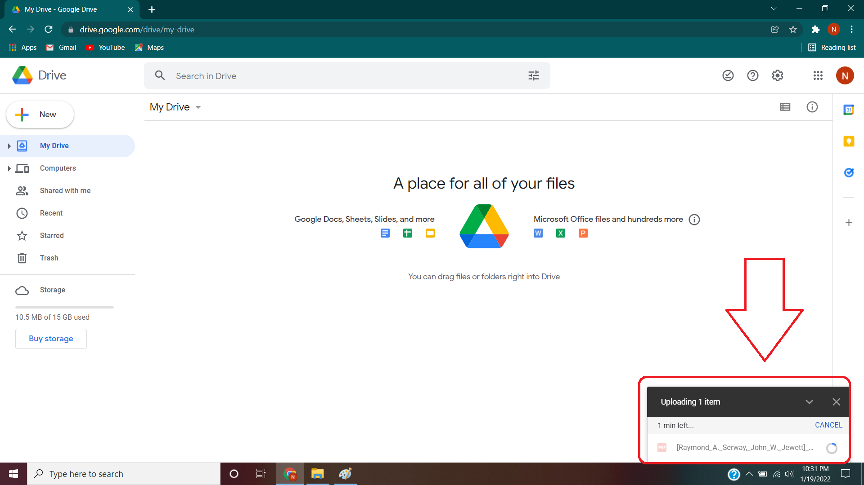

1. **NOW OPEN GMAIL IN CHROME**

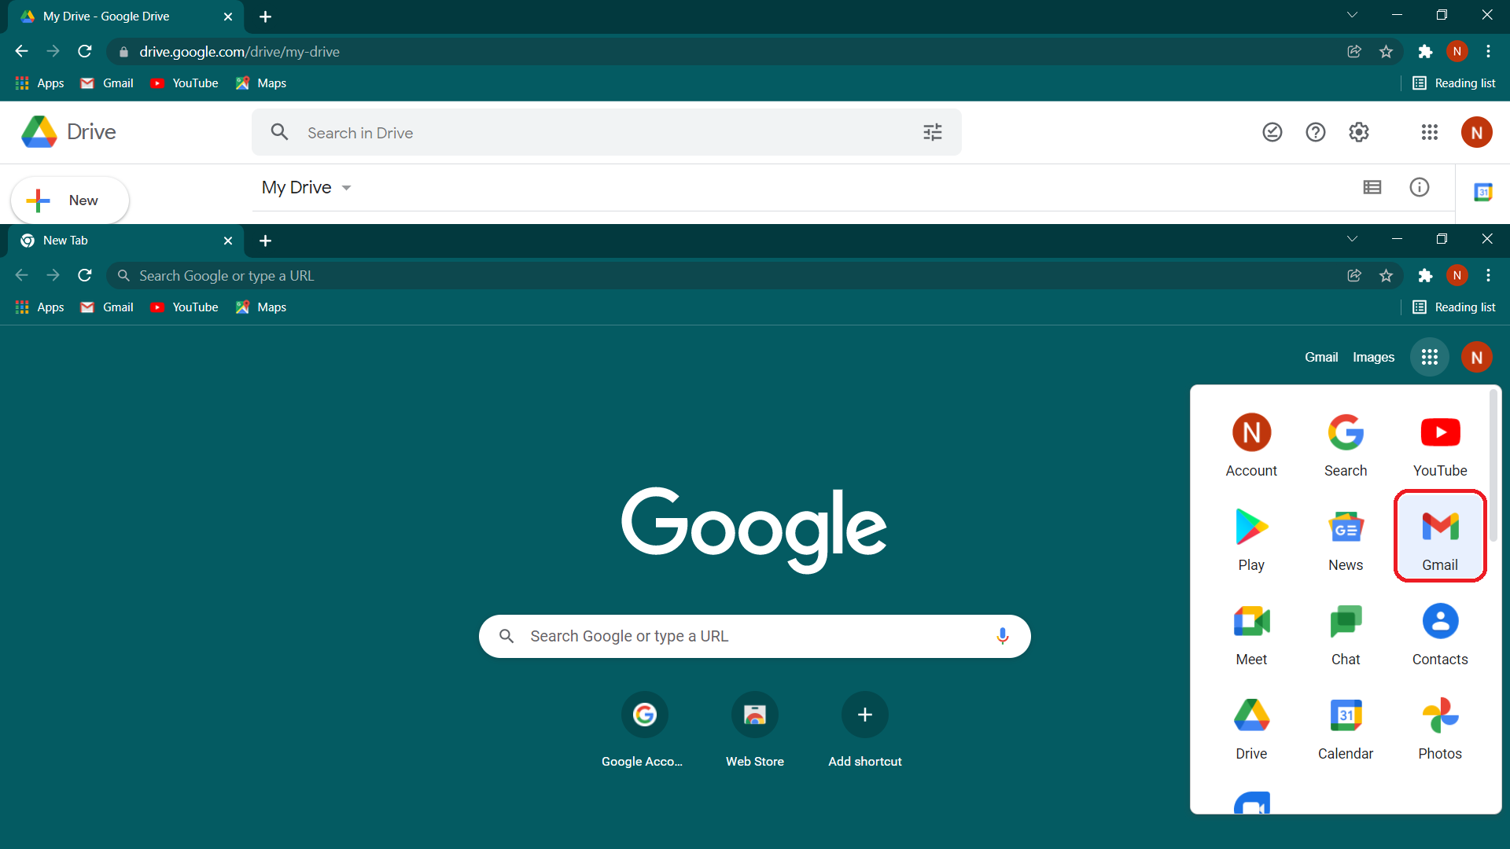

1. **CLICK ON COMPOSE**

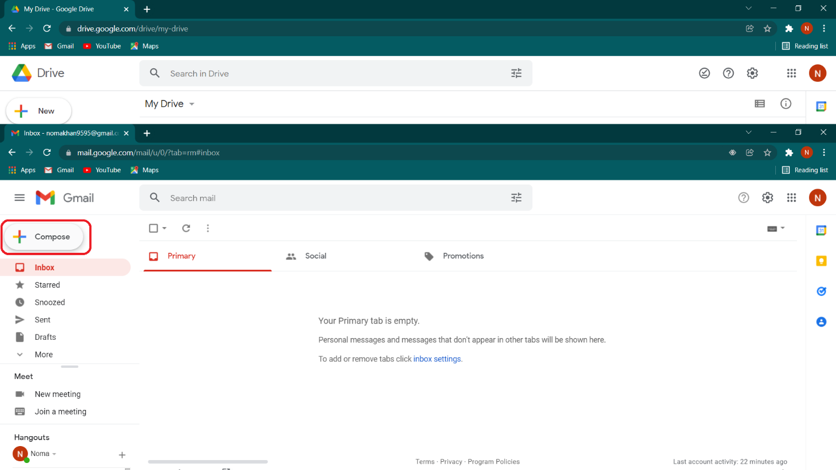

1. **CLICK ON THE GOOGLE DRIVE ICON BELOW**

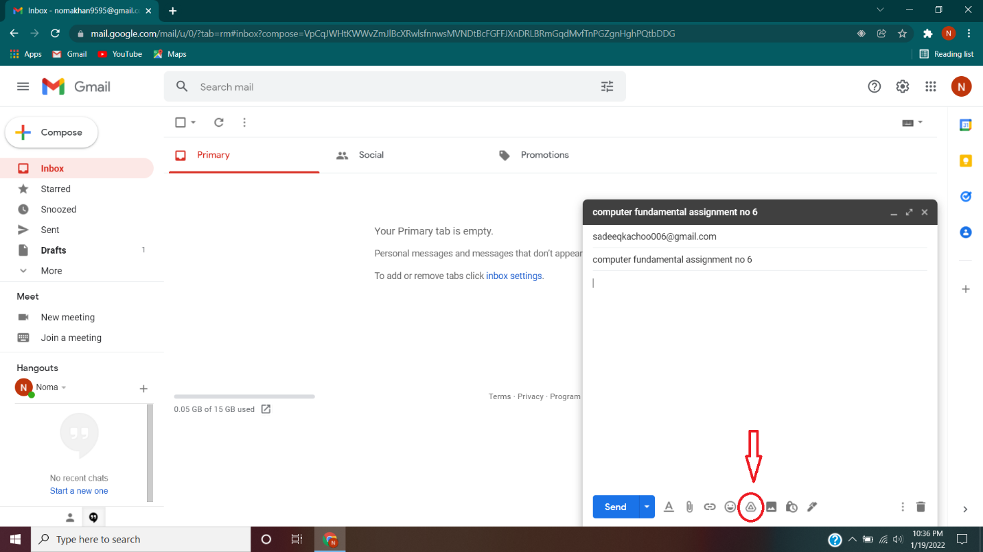

1. **INSERT THE FILE YOU JUST UPLOAD FOR SENDING TO SOMEONE**

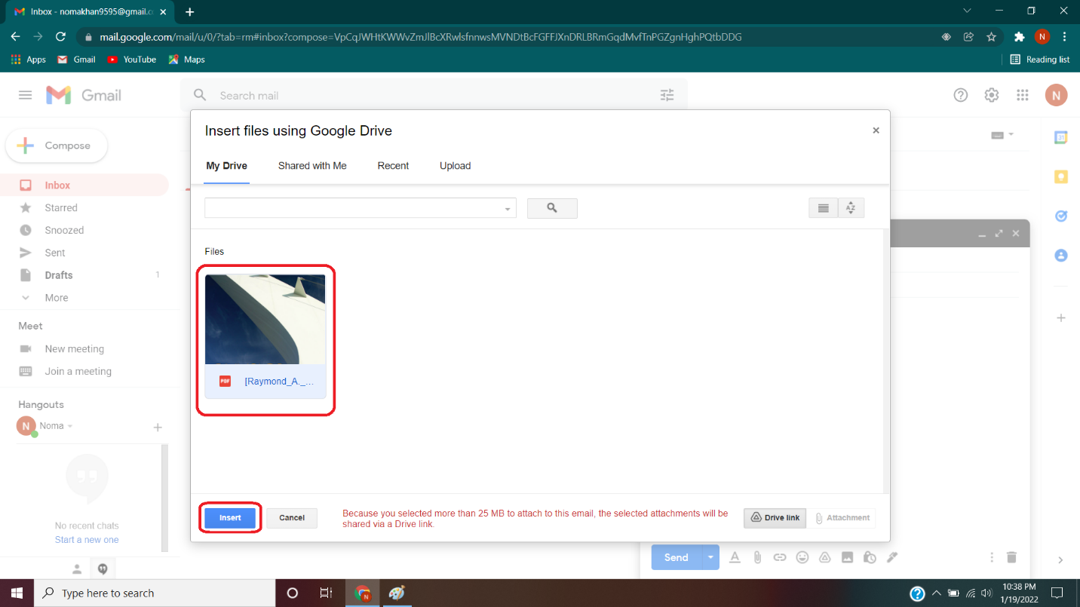

1. **CLICK ON SEND**

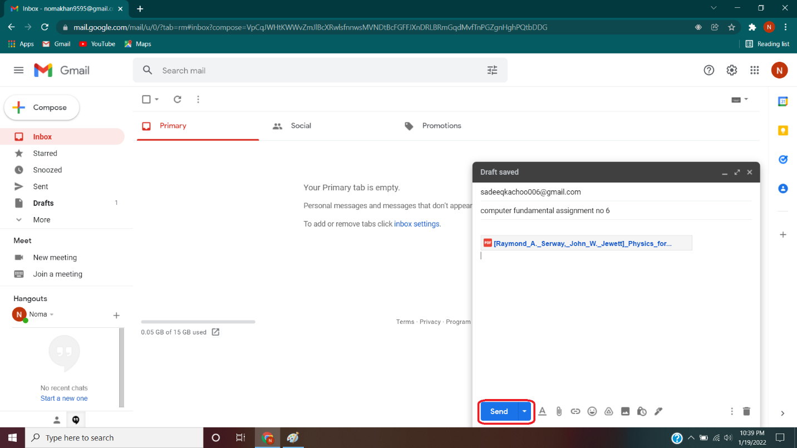

1. **SELECT THE OPTION YOU WANT TO SHARE IT WITH SINGLE PERSON OR TO ANYONE THEN CLICK SEND**

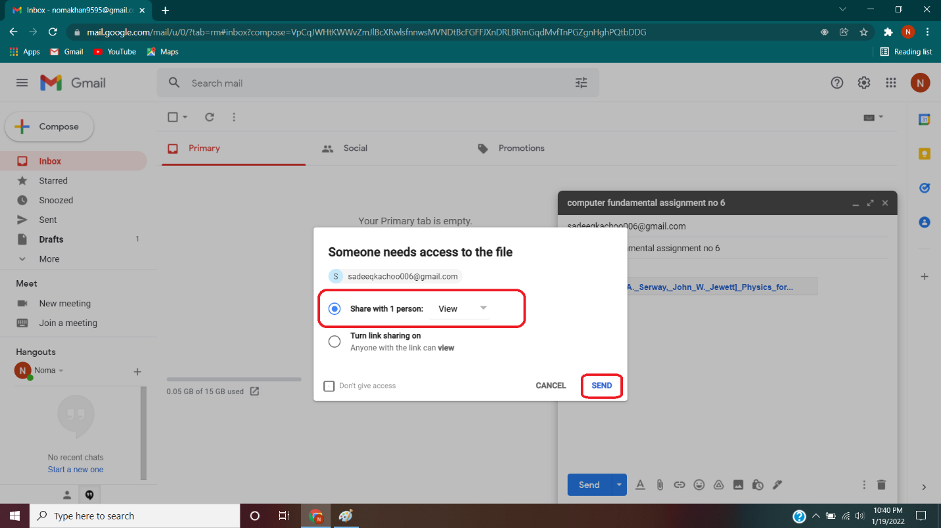

1. **THE EMAIL WILL BE SENT TO THE PERSON WITH THE ATTACHMENT AND YOU WILL GET A SMALL NOTIFICATION BELOW**

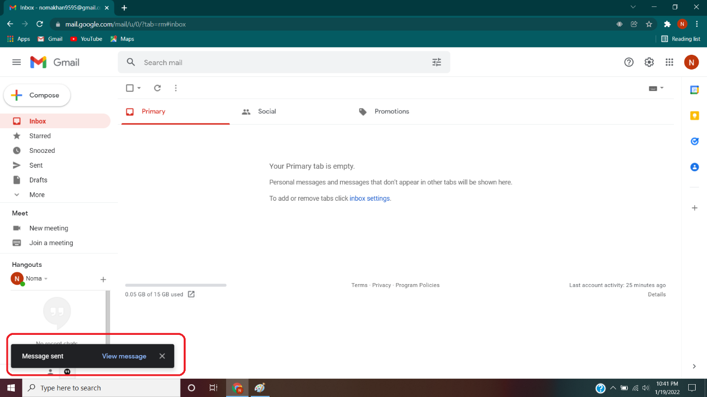

HOW YOU WILL ACCESS A WI-FI ROUTER ADMIN PANEL

1. **OPEN RUN COMMAND TYPE “CMD” IN IT AND THEN PRESS “ENTER”**

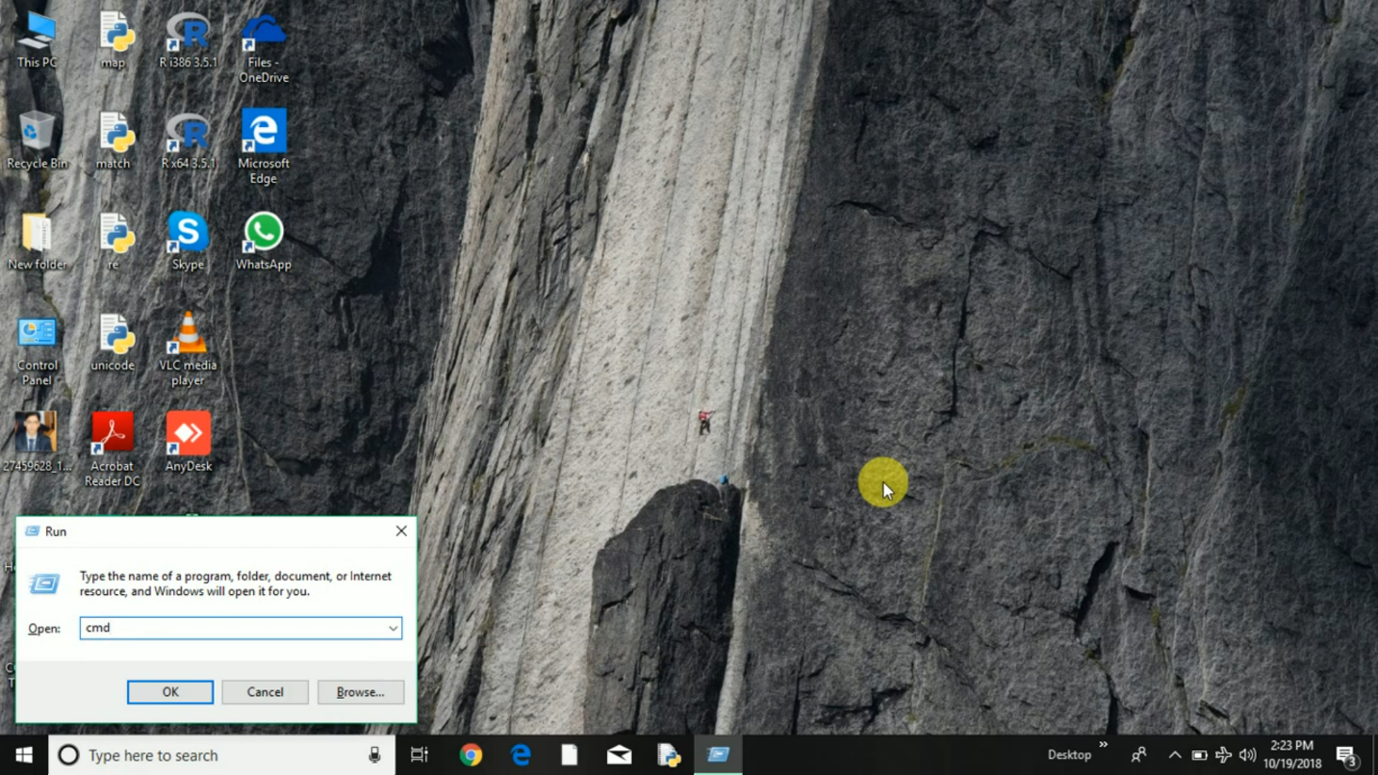

1. **TYPE “IPCONFIG” AND PRESS ENTER**

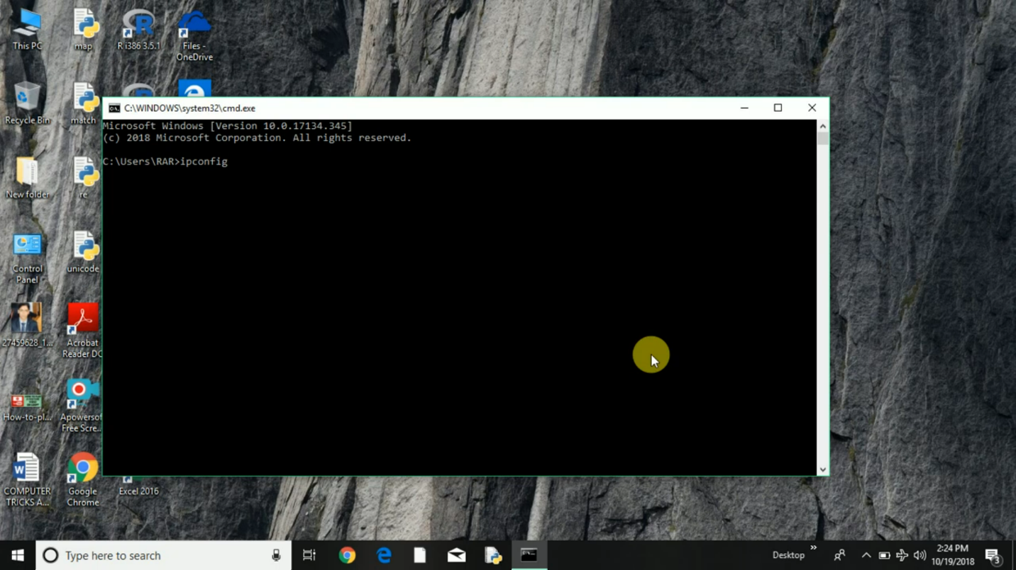

1. **COPY THE DEFAULT GATEWAY IP ADDRESS**

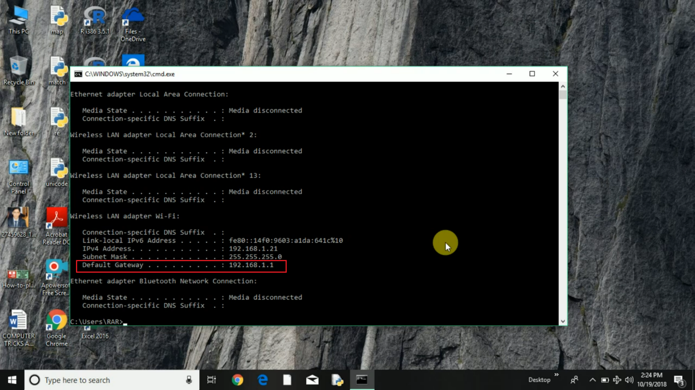

1. **TYPE THE DEFAULT GATEWAY IP ADDRESS IN SEARCH MENU IN CHROME OR ANY BROWSER AND PRESS ENTER**

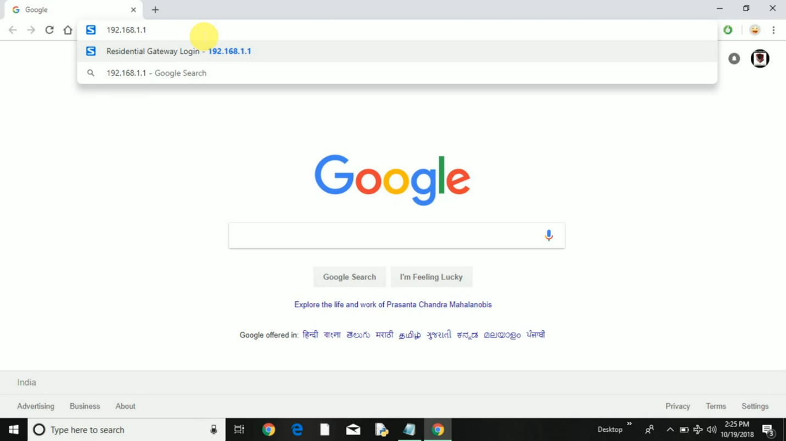

1. **ENTER YOUR USER NAME AND PASSWORD AND LOGIN**

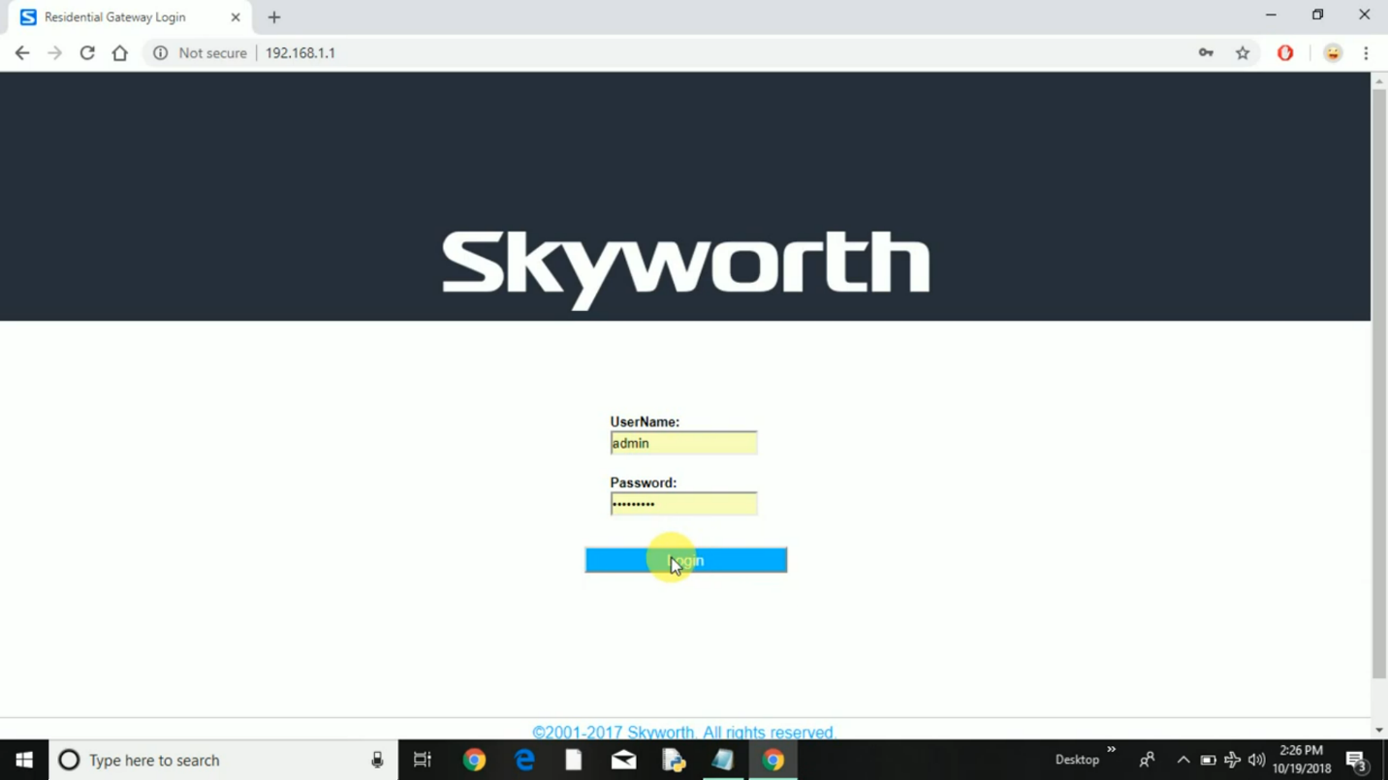

1. **YOU WILL ENTER TO YOUR ROUTER ADMIN PANEL HERE YOU CAN CHANGE YOUR ROUTER SETTINGS**

